Lindenwood University’s College of Education and Human Services (COEHS) systematically collects and analyzes multiple sources of completer data to evaluate the effectiveness of its educator preparation programs and the impact of program completers on P–12 student learning and development.
This evidence narrative addresses CAEP Standard 4 Program Impact:
- R4.1: Completer Effectiveness
- R4.2 Satisfaction of Employers
- R4.3 Satisfaction of Completers
The findings presented are based on analysis of completer self-report data and employer evaluations aligned to the Missouri Teacher Standards.
This analysis integrates multiple data sources to evaluate the effectiveness of Lindenwood University's teacher preparation programs:
1. Alumni Survey (Audience size: 366. Surveys started 36, Surveys finished 34, Response rate 10%, Completion rate 94%)
2. First-Year Teacher's Principal Evaluation 2025
3. Faculty Analysis

Certification Area | Count N=34 | Percent
Early Childhood | 3 | 10%
Early Childhood Special Education | 1 | 3%
Elementary | 13 | 42%
Middle School Business 5-9 | 0 | 0%
Middle School Language Arts 5-9 | 0 | 0%
Middle School Science 5-9 | 0 | 0%
Middle School Mathematics 5-9 | 1 | 3%
Middle School Social Studies 5-9 | 2 | 6%
Biology 9-12 | 1 | 3%
Chemistry 9-12 | 0 | 0%
Business 9-12 | 0 | 0%
English 9-12 | 1 | 3%
Mathematics 9-12 | 0 | 0%
Social Studies 9-12 | 3 | 10%
Art K-12 | 1 | 3%
Music: Vocal K-12 | 0 | 0%
Music: Instrumental K-12 | 2 | 6%
Physical Education K-12 | 3 | 10%
Alumni Survey
Characteristics of Responding Teachers
Ethnicity | Count N=34 | Percent
Black or African American | 1 | 3%
Hispanic or Latino | 0 | 0%
White | 32 | 94%
Prefer not to say | 1 | 3%

Gender | Count | Percent
Male | 4 | 12%
Female | 28 | 85%
Prefer not to say | 1 | 3%

CAEP Standard 4 Program Impact R4.1: Evidence of Completer Effectiveness
CAEP Expectation: The provider demonstrates that program completers effectively apply professional knowledge, skills, and dispositions.
When asked to rate their teaching effectiveness on a 5-point scale (5=Very Effective; 4=Effective; 3=Moderately Effective; 2=Somewhat Effective; 1=Not Very Effective), most Alumni respondents rated themselves as “Somewhat Effective,” "Effective" or "Very Effective." Similarly, graduates reported strong confidence in their positive impact on P-12 learners.
Teaching Effectiveness
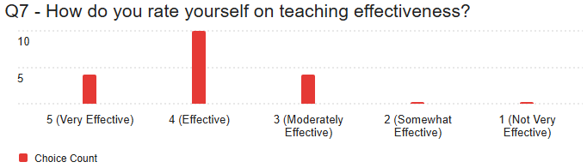
Positive Impact on P-12 Learners
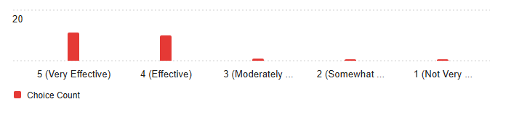
N=22 | Teaching Effectiveness | Positive Impact on K-12 Learning
5 - Very Effective | 18% | 50%
4 - Effective | 59% | 45%
3 - Moderately Effective | 23% | 5%
2 – Somewhat Effective | - | -
1 - Not Very Effective | - | -
Across all nine Missouri Teacher Standards, Alumni respondents predominantly rated themselves as "Skilled Candidates" (3) or "Exceeding Candidates" (4), indicating confidence in their professional competencies. The strongest self-ratings appeared in: Standard 8 (Professionalism), Standard 6 (Effective Communication) and Standard 9 (Professional Collaboration)

Standard 1 - Content Knowledge | Percentage | Count
4 (Exceeding Candidate) | 40% | 6
3 (Skilled Candidate) | 47% | 7
2 (Developing Candidate) | 7% | 1
I prefer not to share | 7% | 1
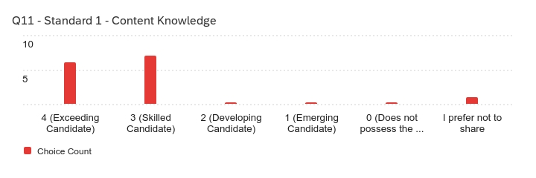
Standard 2 - Student Learning, Growth, and Development | Percentage | Count
4 (Exceeding Candidate) | 47% | 7
3 (Skilled Candidate) | 47% | 7
2 (Developing Candidate) | 7% | 1
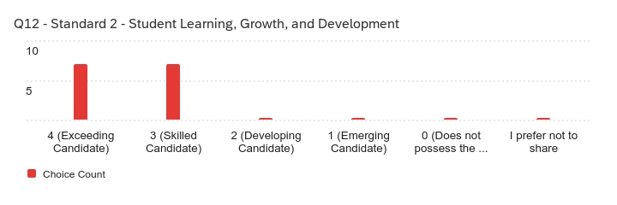
Standard 3 - Curriculum Implementation | Percentage | Count
4 (Exceeding Candidate) | 47% | 7
3 (Skilled Candidate) | 47% | 7
2 (Developing Candidate) | 7% | 1
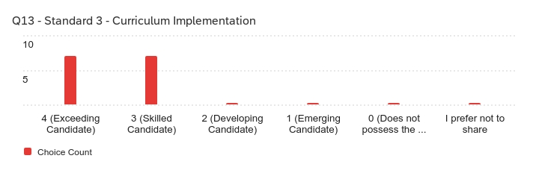
Standard 4 - Critical Thinking | Percentage | Count
4 (Exceeding Candidate) | 50% | 7
3 (Skilled Candidate) | 43% | 6
2 (Developing Candidate) | 7% | 1
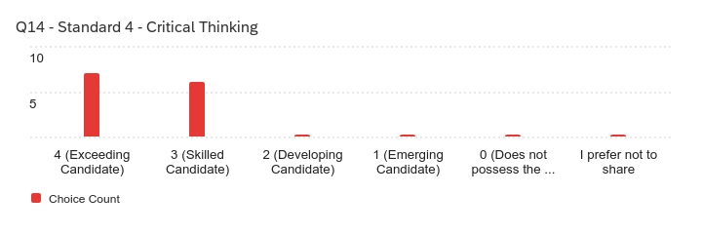
Standard 5 - Positive Classroom Environment | Percentage | Count
4 (Exceeding Candidate) | 67% | 10
3 (Skilled Candidate) | 27% | 4
2 (Developing Candidate) | 7% | 1

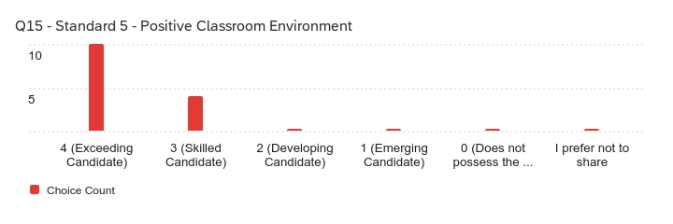
Standard 6 - Effective Communication | Percentage | Count
4 (Exceeding Candidate) | 53% | 8
3 (Skilled Candidate) | 33% | 5
2 (Developing Candidate) | 7% | 1
I prefer not to share | 7% | 1

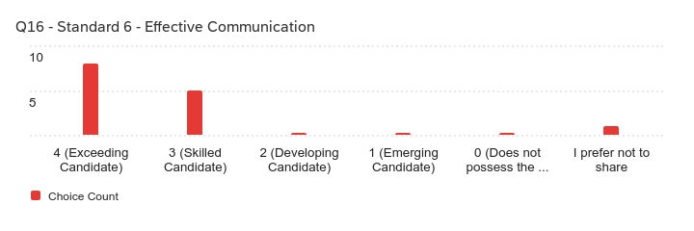
Standard 7 - Student Assessment and Data Analysis | Percentage | Count
4 (Exceeding Candidate) | 27% | 4
3 (Skilled Candidate) | 53% | 8
2 (Developing Candidate) | 13% | 2
I prefer not to share | 7% | 1

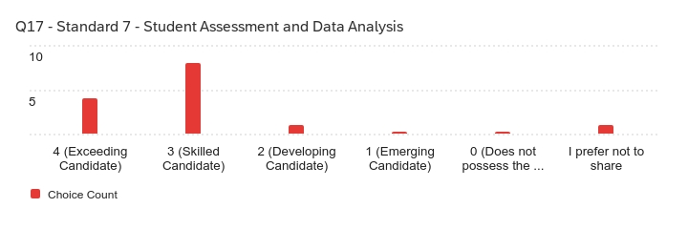
Standard 8 - Professionalism | Percentage | Count
4 (Exceeding Candidate) | 60% | 9
3 (Skilled Candidate) | 33% | 5
2 (Developing Candidate) | 7% | 1

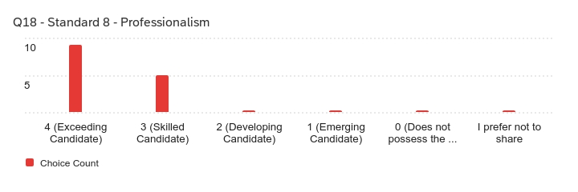
Standard 9 - Professional Collaboration | Percentage | Count
4 (Exceeding Candidate) | 53% | 8
3 (Skilled Candidate) | 33% | 5
2 (Developing Candidate) | 7% | 1
I prefer not to share | 7% | 1

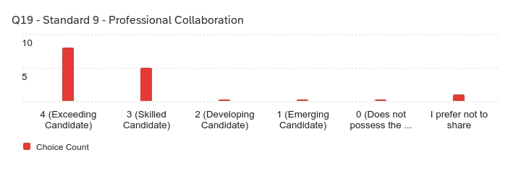
These findings are corroborated by employer evaluations. Principals supervising first-year Lindenwood graduates rated completers positively across all Missouri Teacher Standards, with overall standard means ranging from approximately 3.67 to 3.93 on a five-point scale. Highest ratings were noted in Effective Communication, Professional Collaboration, and fostering positive student relationships, indicating that completers are effectively applying professional knowledge and skills in P–12 settings.
R4.2: Satisfaction of Employers- Evidence of Completer Impact on P–12 Student Learning and Development
CAEP Expectation:
The provider demonstrates that program completers have a positive impact on P–12 student learning, growth, and development.
Evidence from both completer self-reports and principal evaluations demonstrates that Lindenwood University graduates positively impact P–12 student learning and development. Alumni participating in the 2025-2026 survey reported high levels of perceived impact, with most completers rating their influence on student learning as Effective or Very Effective. Alumni described impact through student academic growth, engagement, assessment data, and the creation of supportive classroom environments.
Performance-based evaluations completed by principals further validate these findings. Seventy-eight percent of principals rated first-year teachers as Effective or Highly Effective in their overall impact on students, and seventy-eight percent rated them as Effective or Highly Effective in achieving expected levels of student growth. These results provide strong external evidence that Lindenwood completers positively influence P–12 learner outcomes.
R4.3: Completer Satisfaction with Preparation
CAEP Expectation:
The provider demonstrates that program completers perceive their preparation as relevant and effective.
Lindenwood University demonstrates completer satisfaction with preparation through alumni and employer feedback regarding overall program quality. Results from the 2025-2026 Alumni Survey indicate that most respondents rated the quality of their professional education program as Good or Very Good. Alumni consistently identified preparation in instructional foundations, relationship-building, professionalism, and collaboration as program strengths.
Employer perceptions further support completer satisfaction with preparation. Principals rated the overall quality of Lindenwood’s teacher preparation programs with a mean score of 3.97 on a five-point scale, indicating strong satisfaction with the preparation completers received prior to entering the profession.
While both alumni and principals expressed high levels of satisfaction, they also identified areas for improvement, including classroom management, differentiation, literacy instruction, and preparation for diverse learner needs. These findings reflect thoughtful, experience-based feedback from completers and employers and are used to inform ongoing program improvement.
Identified Challenges and Areas for Growth
Alumni-Identified Challenges
Alumni were asked to identify the most difficult challenges faced when striving to meet student needs. Dominant themes included:
- Classroom and behavior management
- Supporting students with diverse learning and behavioral needs
- Communicating effectively with parents and caregivers
- Balancing academic instruction with social-emotional and behavioral demands
Principal-Identified Challenges
Principal open-ended responses echoed alumni feedback, with repeated references to:
- Classroom management and student behavior
- Transitions and pacing
- Differentiation for diverse learners, including gifted students and students with disabilities
- Literacy and instructional decision-making
The alignment between alumni and principal feedback suggests accurate self-assessment by completers and clearly defined areas for continued program improvement.
Program Quality and Preparation
Alumni rated the overall quality of the professional education program positively, with most respondents selecting Good or Very Good. Similarly, principals rated the overall quality of preparation highly, with a mean program quality rating of 3.97 on a five-point scale. These ratings indicate strong satisfaction with program preparation while still identifying areas for targeted enhancement.
Use of Data for Continuous Improvement
In alignment with CAEP expectations, Lindenwood University uses completer effectiveness and impact data to guide continuous program improvement. Based on alumni and principal feedback, the College of Education and Human Services has identified the following priority areas:
- Expanded instruction and practice in classroom management and behavior support
- Increased focus on differentiation, including ELL, gifted, and special education strategies
- Enhanced preparation for literacy instruction across content areas
- Continued emphasis on relationships, SEL, and trauma-informed approaches
These priorities inform course revisions, field experience expectations, and refinement of key assessments to ensure continued responsiveness to P–12 classroom realities.
Department Head Response
As Department Head, I have reviewed the alumni survey results, principal evaluations of first-year teachers, and faculty analyses presented in this report. Collectively, these data provide strong evidence that completers of Lindenwood University’s educator preparation programs are effectively applying professional knowledge, skills, and dispositions in P–12 settings, consistent with CAEP Standard 4 expectations.
Employer feedback offers particularly compelling external validation of program effectiveness. Principals supervising first-year Lindenwood graduates rated the overall quality of preparation at a mean of 3.97 on a five-point scale, and 78% of principals rated graduates as Effective or Highly Effective in both their overall impact on students and their ability to achieve expected levels of student growth. These findings align with alumni self-reports describing strong confidence in their instructional effectiveness and positive impact on student learning.
Across the Missouri Teacher Standards, principals most consistently affirmed completer strengths in Effective Communication, Professional Collaboration, and Positive Classroom Environment. Notably, principals rated graduates highly in fostering positive student relationships (M = 4.27) and collaborating with colleagues to support student learning (M = 4.08). These strengths are echoed in alumni self-assessments and reflect sustained program emphasis on relationship-building, professionalism, and collaborative practice.
At the same time, both employer and completer data identify clear and consistent areas for growth. Principal mean ratings were comparatively lower in areas related to classroom management and behavior support (e.g., managing discipline issues, M = 3.51; use of classroom management strategies, M = 3.65), as well as instructional differentiation for English learners and gifted students (both M = 3.51). Literacy preparation, particularly differentiating instruction for struggling readers (M = 3.37) also emerged as an area for targeted enhancement. These findings mirror alumni-identified challenges and faculty observations, reinforcing the validity of the data and highlighting authentic first-year teaching needs.
In response, the College of Education and Human Services has prioritized programmatic improvements that directly address these findings. Current and planned actions include enhanced coursework and field-based practice in classroom management and behavior support, expanded instruction in differentiation across learner populations, increased emphasis on literacy instruction across content areas, and continued integration of trauma-informed and SEL-focused practices. Faculty are using these data to guide course revisions, strengthen clinical expectations, and refine key assessments to ensure graduates are well prepared for the realities of today’s classrooms.
Overall, the convergence of alumni perceptions, employer evaluations, and faculty analysis provides strong evidence that Lindenwood University’s educator preparation programs are producing effective beginning teachers who positively impact P–12 student learning. Equally important, these data inform a clear and focused plan for continuous improvement, reflecting the unit’s commitment to responsive, evidence-based program development.

